# Ideation Phase Customer Care Registry

|  |  |
| --- | --- |
| Date | 19 September 2022 |
| Team ID | PNT2022TMID31029 |
| Project Name | Customer Care Registry |
| Maximum Marks | 4 Marks |

**Brainstorm & Idea:**

# Implement support ticket tagging automation using AI.

The customer raises the problem in the websites. To get support ticket insights, you can manually analyze all your customer service channels and consolidate them under one roof. But it’s frustratingly time-consuming and manual ticket tagging leaves room for human error and discrepancies. If you use multiple people on your team to tag tickets, it becomes ever harder to train agents to understand tickets and tag them in a uniform way. Using AI powered ticket tagging platform, we can track the topic and sentiment of every email, chat, review and survey in real-time. Our AI automatically tagged all qualitative text under different segments and sub segments, the ‘rising topics’ are then distributed every day to other department leads.

# Implement a website-based Chabot system.

Okay, we aren’t bringing something totally innovative to the conversation here...but if you don’t have a live chat with a degree of automation, you need to experiment with it. If you are on a website for the first and the third reason, a live chat would be a great aggregator in helping you solve your problems.

# Create a knowledge base or a self-service hub.

Creating a knowledge-based shows your customers you care and reduce support ticket volume. A knowledge base is a collection of resources about your product/services. Providing the right details at the right time is part of a great customer experience. Knowledge bases allow your customers to access the right information to solve their own problems and queries. For you, a knowledge base works particularly well because they reduce the effort your team puts in to those frequent queries. Analyze your support tickets to work out what those easy-to answer, repetitive questions are and write a short article to address the problem.

**Reference:** https://app.mural.co/invitation/mural/ibm5491/1664041851382?sender=u2c4be893618385e8 f6b05382&key=f8ac3bbd-ff36-4e94-b8d3-d87487b15602

# Step-1: Team Gathering, Collaboration and Select the Problem Statement

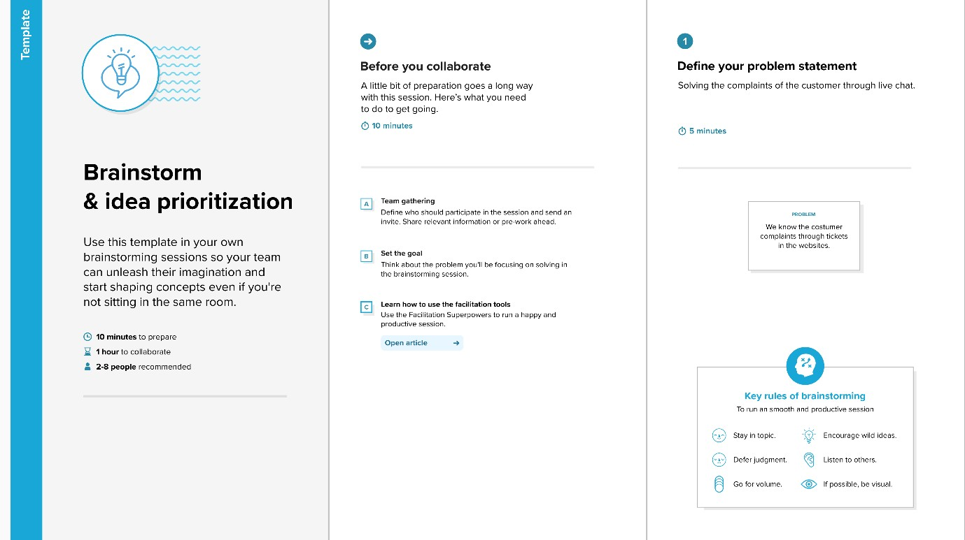

**Step-2: Brainstorm, Idea Listing and Grouping**

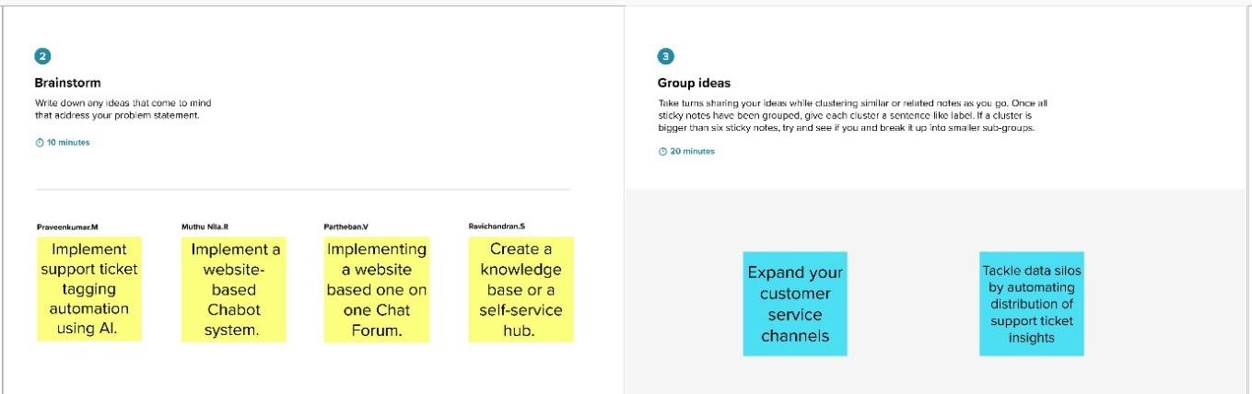

# Step-3: Idea Prioritization

